Reference Tutorial from Blender Manual

**Outliner**

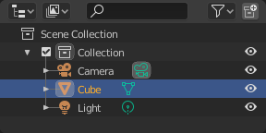

*The Outliner editor.*

The *Outliner* is a list that organizes data in the blend-file, i.e. the scene data, Video Sequencer data, or anything that gets stored in a blend-file. The *Outliner* can be used to:

* View the data in the scene.
* Select and deselect objects in the scene.
* Hide or show an object in the scene.
* Enable or disable selection (to make an object “unselectable” in the 3D Viewport).
* Enable or disable the rendering of an object.
* Delete objects from the scene.
* Unlink data (equivalent to pressing the *X* button next to the name of a data-block).
* Manage collections in the scene.

Each row in the *Outliner* shows a data-block. You can LMB click the disclosure triangle to the left of a name to expand the current data-block and see what other data-blocks it contains. Holding Shift when clicking on the disclosure triangle will expand child data-blocks recursively. LMB Clicking and dragging along disclosure triangles will expand or collapse multiple data-blocks.

**Selecting and Activating**

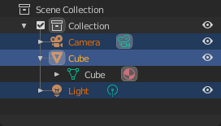

*Selected data-blocks with the Cube active.*

Selection is done with LMB (and/or the [context menu](https://docs.blender.org/manual/en/2.81/editors/outliner.html#context-menu), see below) on the row of a data-block outside the name/icon area. Single selections will also activate the data-block. The rows of selected data-blocks are highlighted blue, with the active data-block highlighted in a lighter blue.

Clicking in empty space below the list of data-blocks will deselect all.

**Note**

By default, selecting data-blocks in the Outliner will select the respective objects, bones, and sequences in the 3D View and Sequencer. Selections in the 3D View and Sequencer will be synced to each Outliner. To disable selection syncing, turn off the toggle in the [filter](https://docs.blender.org/manual/en/2.81/editors/outliner.html#filter) popover.

Children of a data-block can also be selected by clicking the icon that is displayed to the right of the parent data-block’s name.

**Selecting Multiple Data-Blocks**

Extend the selection one data-block at a time using Ctrl-LMB. Each data-block added to the selection this way will be made the active data-block.

Select a range of elements from the active element using Shift-LMB. To select a range without deselecting the previous selection, use Shift-Ctrl-LMB.

A click and drag from any location in the Outliner other than a name or icon will begin a box selection. Use Shift to add and Ctrl to subtract from existing selections with box select. Box select can also be started with B.

To select all items use A; Alt-A will deselect all items.

The keyboard arrow keys can be used to navigate and select in the Outliner. Keyboard selection and navigation starts from the active data-block, but does not change the active data-block.

|  |  |
| --- | --- |
| Up | Select the previous element in the list. |
| Down | Select the next element in the list. |
| Shift-Up | Select the previous element without deselecting. |
| Shift-Down | Select the next element without deselecting. |
| Left | Close the data-block. |
| Right | Open the data-block to view children. |
| Shift-Left | Close this and all child data-blocks. |
| Shift-Right | Open this and all child data-blocks. |

**Toggling Interaction Modes**

Selecting some data-blocks with LMB will toggle into the relevant interaction mode. For example, selecting the mesh data of the cube will select the cube and enter *Edit Mode*. Selecting the data-block again will toggle back into *Object Mode*

If the data-block type supports multi-editing, you can use Shift to add/remove objects from the edit mode.

**Relations Management**

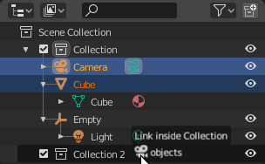

*Linking objects to a collection.*

Data-blocks can be dragged and dropped to manage data relations in the Outliner. To begin a drag and drop, LMB click and drag from the name or icon of a data-block.

Objects can be moved to collections by dropping on the name or contents of a collection. To link an object to a collection, hold Ctrl while dropping.

To set parent-child relations between objects, drop an object onto another object while holding Shift.

**Note**

Drag and drop will attempt to operate on the entire selection. Selected data-blocks that are incompatible with the operation will remain unmodified.

**Context Menu**

Show the context menu for a data-block with RMB on the icon or name. Depending on the type of the preselected data-block(s), you will have all or part of the following options:

**Copy/Paste**

Copy/pastes selected data-blocks.

**Delete**

Deletes the selected data-block.

**Select, Select Hierarchy, Deselect**

Add object to current selection without making it the active one.

**Collections**

Collections are a way Blender uses to organize scenes. Collections contain objects and everything thing else in a scene. They can include collections themselves and are fully recursive.

**See also**

Read more about [Collections](https://docs.blender.org/manual/en/2.81/scene_layout/collections/index.html)

**New**

Creates a new collection.

**Duplicate Collections**

Recursively duplicates the collection including all child collections, objects, and object data.

**Duplicate Linked**

Duplicate entire hierarchy keeping content linked with original.

**Delete Hierarchy**

Deletes the collection and all of its child objects.

**Instance to Scene**

Creates a new [collection instance](https://docs.blender.org/manual/en/2.81/scene_layout/object/properties/instancing/collection.html).

**Visibility**

**Isolate**

Hides all collections except the selected collection and any parent collections (if any exist).

**Show/Hide**

Shows/Hides the selected collection from the [View Layer](https://docs.blender.org/manual/en/2.81/scene_layout/view_layers/index.html).

**Show/Hide Inside**

Shows/Hides all items that are a member of the selected collection, include child collections, from the [View Layer](https://docs.blender.org/manual/en/2.81/scene_layout/view_layers/index.html).

**Enable/Disable in Viewports**

Enables/disables drawing in the [View Layer](https://docs.blender.org/manual/en/2.81/scene_layout/view_layers/index.html).

**Enable/Disable in Renders**

Enables/disables visibility of the collection in renders.

**View Layer**

**Disable/Enable in View Layer**

Disables/Enables the collection from the view layer.

**ID Data Menu**

**Unlink**

To unlink a data-block from its “owner” (e.g. a material from its mesh).

**Make Local**

To create a “local” duplicate of this data-block.

**Make Single User**

This feature is not yet implemented.

**Delete**

Deletes the selected data-block.

**Remap Users**

Remap Users of a data-block to another one (of same type of course). This means you can e.g. replace all usages of a material or texture by another one.

**Copy/Paste**

Copy/pastes selected data-blocks.

**Add Fake User, Clear Fake User**

Adds a “dummy” (fake) user so that the selected data-block always gets saved even if it has no users. The fake user can be removed with *Clear Fake User*.

**Rename**F2

Renames the selected data-block.

**Select Linked**

Selects the linked data, see [Select Linked](https://docs.blender.org/manual/en/2.81/scene_layout/object/selecting.html#bpy-ops-object-select-linked) for more information.

**View Menu**

The view menu is part of the context menu and supported in all the Outliner elements.

**Show Active**

Centers the Tree View to selected object Period.

**Show Hierarchy**

To collapse all levels of the tree Home.

**Show/Hide One Level**

Expand one level down in the tree NumpadPlus and NumpadMinus to collapse.

**Note**

Some data-block types will not have a context menu at all!

**Restriction Columns**

The following toggles, in the right side of the *Outliner* editor, are available for collections, objects, bones, modifiers and constraints.

By default only the temporary viewport visibility is enabled. The other options can be enabled in the *Restriction Toggles* option in the Outliner [filter](https://docs.blender.org/manual/en/2.81/editors/outliner.html#filter).

* Holding Shift sets or unsets the value to all its child collections or objects.
* Holding Ctrl isolates the object or collection, so they are the only ones with its value set.

**Visibility (eye icon)**

Toggles the visibility of the object in the 3D View.

**Enable collection (checkbox)**

Exclude the collection from the view layer. This is not really a restriction column. It is shown besides the collection icon.

**Note**

The following options need to first be enabled in the Outliner filter.

**Selectability (mouse cursor icon)**

This is useful for if you have placed something in the scene and do not want to accidentally select it when working on something else.

**Rendering (camera icon)**

This will still keep the object visible in the scene, but it will be ignored by the renderer. Usually used by support objects that help modeling and animation yet do not belong in the final images.

**Global Viewport Visibility (screen icon)**

This will still render the object/collection, but it will be ignored by all the viewports. Often used for collections with high-poly objects that need to be instanced in other files.

**Holdout (collection only)**

Mask out objects in collection from view layer – *Cycles only*.

**Indirect Only (collection only)**

Objects in these collections only contribute to indirect light – *Cycles only*.

**Header**

**Display Mode**

The editors header has a select menu that let you filter what the Outliner should show. It helps to narrow the list of objects so that you can find things quickly and easily.

**Scenes**

Shows *everything* the *Outliner* can display (in all scenes, all view layers, etc.).

**View Layer**

Shows all the collections and objects in the current view layer.

**Sequence**

Lists [data-block](https://docs.blender.org/manual/en/2.81/files/data_blocks.html) that are used by the [Sequencer](https://docs.blender.org/manual/en/2.81/video_editing/index.html).

**Blender File**

Lists all data in the current blend-file.

**Data API**

Lists every [data-block](https://docs.blender.org/manual/en/2.81/files/data_blocks.html) along with any properties that they might have.

**Orphan Data**

Lists [data-blocks](https://docs.blender.org/manual/en/2.81/files/data_blocks.html) which are unused and/or will be lost when the file is reloaded. It includes data-blocks which have only a fake user. You can add/remove Fake User by clicking on cross/tick icon in the right side of the Outliner editor.

**Searching**

You can search the view for data-blocks, by using Search field in the header of the *Outliner*, The [Filter](https://docs.blender.org/manual/en/2.81/editors/outliner.html#filter) menu lets you toggle the following options:

* Case Sensitive Matches Only
* Complete Matches Only

**Filter**

**Restriction Toggles**

Set which [Restriction Columns](https://docs.blender.org/manual/en/2.81/editors/outliner.html#restriction-columns) should be visible.

**Sort Alphabetically**

Sort the entries alphabetically.

**Sync Selection**

Sync Outliner selection to and from the [3D View](https://docs.blender.org/manual/en/2.81/editors/3dview/index.html) and [Sequencer](https://docs.blender.org/manual/en/2.81/video_editing/index.html) editors. Disable to manage collections, object relations, and scene data without changing the selection state. Selection syncing is only available in Scenes, View Layer, and Sequence display modes.

**Collections**

List the objects and collections under the [collection hierarchy](https://docs.blender.org/manual/en/2.81/scene_layout/collections/index.html) of the scene. Objects may appear in more than one collection.

**Objects**

List of all the objects, respecting the other filter options. Disabled only if you need an overview of the collections without the objects.

**Object State**

**All**

The default option, no restrictions.

**Visible**

List only the objects visible in the viewports. The global and temporary visibility settings are taken into consideration.

**Invisible**

List only the objects not visible in the viewports.

**Selected**

Lists the object(s) that are currently selected in the 3D View. See [selecting in the 3D View](https://docs.blender.org/manual/en/2.81/scene_layout/object/selecting.html) for more information.

**Active**

Lists only the active (often last selected) object.

**Object Contents**

List materials, modifiers, mesh data, …

**Object Children**

List the object children. If the *Collections* option is enabled, you will see the object children even if the children are not in the collection. However the Outliner shows them as a dashed line.

**Data-Block**

Allows you to filter out certain data-blocks currently present in the scene.

**Miscellaneous**

Some options in the header will only show if compatible with the active [Display Mode](https://docs.blender.org/manual/en/2.81/editors/outliner.html#display-mode).

**New Collection (View Layer)**

Add a new collection inside selected collection.

**Filter ID Type (Orphan Data, Blender File)**

Restrict the type of the data-blocks shown in the Outliner.

**Keying Sets (Data API)**

Add/Remove selected data to the active [Keying Set](https://docs.blender.org/manual/en/2.81/animation/keyframes/keying_sets.html).

**Drivers**

Add/Remove [Drivers](https://docs.blender.org/manual/en/2.81/animation/drivers/index.html) to the selected item.

**Purge (Orphan Data)**

Remove all unused data-blocks from the file (cannot be undone).

**Example**

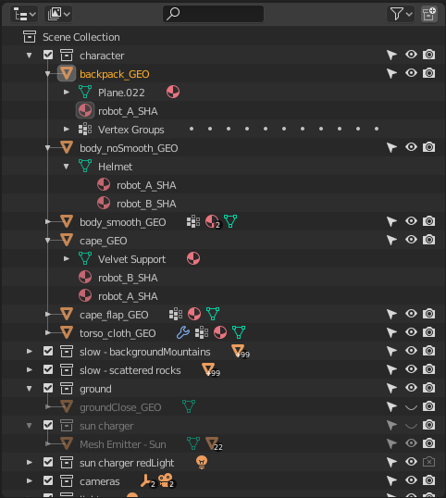

*The Outliner with different kinds of data.*